QUANTITATIVE CHARACTERIZATION OF SPATIALLY EXPLICIT HUNTING BEHAVIORS IN DOMESTIC DOGS, CANIS FAMILIARIS
Budhaditya Chowdhury1,2 ∗, Moira van Staaden1, and Robert Huber1

¹ J. P. Scott Center for Neuroscience, Mind & Behavior, Department of Biological Sciences, Bowling Green State University,Bowling Green OH 43402

² Department of Neurobiology, Harvard Medical School, Goldenson 356, 220 Longwood Avenue, Boston MA 02115

∗ Author for Correspondence (Budhaditya_Chowdhury@hms.harvard.edu)

Introduction

{Budha, This is a really weak beginning, you need to pimp up the first couple of sentences}The domestication of dogs began at least 15,000 years ago (Vilà et al. 1997; Savolainen et al. 2002; Vonholdt et al. 2010). Rigorous artificial selection for a number of morphological and behavioral characteristics has resulted in more than 300 different breeds, of which 170 are recognized by the American Kennel Club (Club 2006). Genetic signs of admixture with wolves is evident in some of the more “ancient” breeds, which have originated >500 years ago (Vonholdt et al. 2010), such as, the Basenji, Akita, and Afghan hound, which were selected for hunting expeditions around 4000 years ago in the Middle East and North Africa (Serpell 1995).
Hunting behavior in canids has been suggested to partition into sequential motor patterns of predatory search, orienting towards prey, pointing, chasing, and biting (Coppinger & Coppinger 2002). In domestication these patterns were selectively amplified to fit specific anthropocentric needs. Pointing dogs, bred to assist humans in open grassland hunting, combine enhanced predatory search patterns with the absence of the chasing sequence (William Arkwright 1906; Coppinger & Coppinger 2002; Miklosi 2008). A successful pointing dog, who has detected game, orients a characteristic frozen stance towards the prey’s hidden location. The maintenance of this behavior in distinct breed lines suggests a significant genetic contribution to the phenotype. Its characterization will contribute to a better understanding of inter-breed heterogeneity as well as intra-breed homogeneity.
Behavioral markers that have been used for canine characterization include the general categories of fearfulness (Mahut 1958), emotionality (Scott & Fuller 1998a), tendency to approach and withdraw in novel situations (Plutchik 1971), learning abilities (Pongrácz et al. 2005), working aptitude (Slabbert & Odendaal 1999), playfulness and activity (Hart & Miller 1985), “reactivity” and “immaturity” (Bradshaw & Goodwin 1999), “personality” (Svartberg & Forkman 2002; Jones & Gosling 2005), and aggression (Cattell & Korth 1973; Netto & Planta 1997; van den Berg et al. 2003).
Although these studies broaden our understanding of canid behavior, the utility of this approach is weakened by its dependence on subjective categorical rating scales. Moreover, the factor aggressiveness used in the personality test of sheltered dogs is not necessarily comparable to the “aggressive” factor in companion dogs (Goodloe & Borchelt 1998), or to the factor used to assess aggression in German Shepherds and Belgian Tervueren (Svartberg & Forkman 2002). There seems to be little difference in definitions of “temperament”, “personality”, or “character” (Ruefenacht et al. 2002). Confounding definitions of “temperament”, range from “the degree of liveliness” (Slabbert & Odendaal 1999) to “physical flexibility and intensity of reaction to different environmental stimuli” (Ruefenacht et al. 2002), and makes characterization of behavioral traits challenging and cross-study comparisons impossible. Subjective rating scales put the reliability and validity of the personality tests (Martin & Bateson 2007) under question (Diederich & Giffroy 2006), especially after the findings that owners are not skilled in observing dog behavior, and misinterpretations are a regular occurrence (van den Berg et al. 2003). In dogs traits for hunting performance are robust, can be characterized by objective metrics, and are rendered accessible to quantitative behavioral assessment. Professional hunting associations provide a framework for judging the performance of individual dogs in hunting contexts. The system assesses success in finding hidden prey, overall performance, as well as the posture and tail position during the pointing stance (William Arkwright 1906; Club 2006). Some of these assessments are confounded by observations on a mixture of characters, and others are purely cosmetic. Successful execution of hunting tasks places heavy demands on a variety of the dog's sensory, cognitive, and orientation skills. These include sampling of the environment for significant olfactory stimuli, matching perceptive signatures with a specific search image, and ultimately guiding the process towards a successful conclusion in the form of pointing behavior (Miklosi 2008). Selected to be performed in the company of the human handler, hunting also requires strong cooperative skills. The active searching area of the dog around the human hunter is known as the range of the dog (Wolters 1961), whereas the location of the dog relative to the human hunter at any given time during the hunt is described as “quartering” (Lamb 2006). Ranges have been suggested to vary considerably among pointing breeds of dogs as well as between individuals within a breed. Moreover, dogs with superior quartering skills are more likely to search areas in front and on either side of the human hunter rather than trailing behind. Such perceptual skills related to hunting are often subtle and run the risk of being overlooked by simple observations. Also, the variability in the dog–handler relationship in a hunt trial is not adequately captured with subjective categorization. Pointing dog breeds exhibit faculties for the essential hunting traits, including efficient search strategies, spatial abilities, sensitive olfaction and strong aerobic performance. To date, however, a rigorous, quantitative dissection of the different behavioral phenotypes and their variability has been lacking in canine models.
The present study aimed to explore hunting strategies in pointing dogs with objective quantitative approaches. Characterization was done by a host of metrics quantifying a range of behavioral components in the dog’s hunting performance, using methods based on satellite telemetry. We determined interbreed variation in abilities, strategies, and addressed the social effect of the handler under hunting conditions. The goal of this project was to specifically develop measurement tools for characterizing: (i) basic features of running behavior and directionality for hunting where we explore the degree to which individual dogs are able to cover a given area in search of prey by characterizing measures of running speed, degree of turning, directional preference, net distance travelled, and changes in these measures over time during a hunting trial; (ii) different search strategies and their effectiveness by analyzing spatial metrics that reflect how efficiently a dog searches a given area for their quarry, and degree of zig-zagging or sinuosity; and (iii) relations of dogs towards their handlers focusing on how the animals alter their hunting strategies with an eye on party members, how far the dogs range from their handler, the consistency of such ranges, the dog's quartering efficiency, and of its ability to adjust its search patterns to the handler’s movements.

Methods:
Animals and field site:

Two different breeds of hunting dogs (English Pointer; n=8 Brittany; n=4) are used along with two different breeds of non hunting dogs (Labrador retriever; n=2, Labradoodle; n=2) for comparison of behavioral phenotypes. Hunting dogs used in this study include young, untrained pups, trained dogs and field-trial champions (Table 1). The dogs are escorted to the field site by the owners for behavioral quantification.
For behavioral experiments, a 5 hectare square field was selected near Tontogany, Ohio (41°24'34. 55"N, 83°46'24. 35"W). The field characteristics included even grass cover (0.5 meters), unobstructed wind flow, and limited environmental heterogeneity (no trees, no brush, and no water bodies). The dogs are held in their mobile kennels behind a barnpreventing them from observing the experimenter, the handler, or other dogs navigate the field.

Experimental setup:

the handler is asked to walk a 4-sided path (150m X 150m) defined with corner stakes (height: 1.5m) near the center of the experimental field (figure 1a). To provide an authentic hunting experience for the dogs a live game bird is planted in the field for each run. Prior to setting these target birds the experimental field is carefully surveyed to ensure that no other gamebirds are resident. Target birds are held in cages, wrapped with plastic and transported using a utility vehicle (John Deere Gator) to minimize the placement of bird scents in the grass cover during setup. The Gator is driven to all four corners of the square trail before placing the bird at one of several, randomly chosen, predefined locations to minimize stray olfactory markers during transport. The cage with bird is hidden by the grass cover to prevent easy visual detection from a distance. {I dont get what that means, no mention of the farthest stake so far, important?}The farthest stake from the “Start” is selected prior to the experimental runs and the target is placed 15 meters away from the farthest stake (Figure 1a).

Behavioral procedures:

Each dog is allowed to rest for 30 minutes in the mobile kennels prior to the start of its experimental trials. Tested dogs (n = 16) are run three times each separated by a period of at least 30 minutes of rest. In the first scenario, one of the four stakes is randomly chosen as the start location with the target bird in place. In the second scenario, the stake diagonally opposite to the “Start” stake (in the first trial) is chosen as the start location with the target bird in place. In the third scenario, one of the two remaining stakes is randomly chosen as the start location {← I don't get it, what is the point of doing this … more info needed}. The trials are terminated when the dog successfully finds the bird location, or, after a maximum duration of 10 minutes. During the experimental trial the owner walks the square path delineated by the four stakes at a steady pace with folded arms, and is asked to refrain from issuing any commands to the dogs. The dogs are allowed to run freely for the entire duration of experimental trials. 16 dogs … A repeated measures design, with each dog being tested three times ...

Data Analysis
GPS Data

The movements of all dogs and handlers during these trials were recorded using GPS trackers (Garmin Forerunner 205, , Garmin, ...) with track pointsrecorded once per second at ±2m accuracy (Figure 1b). The light-weight GPS receiver (90g) was clipped to the dogs’ collar while the handler carried one in an outside pocket. Spatial tracks were transferred to a computer (Mac OS X ver 10.5.8) via a USB interface and subjected to spatial and circular statistical procedures. Prior to analysis every recorded track was plotted in Google Earth (Pro 5.0, Google, CA, USA) to confirm validity and quality. Visualized tracks were screened for artifacts and irregularities in the data. In one of the tracks several data points were missing, presumably due to an intermittent loss of satellite signal, and the track was excluded from further analysis. The initial processing of the raw GPS data included Haversine transformation of geographic coordinate system to metric measurements.
Data were subjected to spatial and circular analysis of the track coordinates using Java DataGrinders <http://caspar.bgsu.edu/~software/Java/>). Based on the dog’s movements number of linear and circular metrics were extracted for each trial (Figure 3)I, includeing the dog’s mean, maximum, and variance in speed, mean and variance in an index of straightness, the path's fractal dimension, total distance traveled, mean and maximum distance to handler, quartering ability, and proportion of the total area searched. Circular descriptive measures included the dog’s mean direction, relative orientation consistency, mean orientation and orientation consistency towards the handler.
Speed variables were calculated across successive moves between GPS coordinates. Straightness index was calculated by an algorithm that considered the angle between consecutive 1m sections around each point. The euclidian distance (D) was calculated with each move's start and end point. The D/2 ratio measured how much shorter this bee-line was compared to the maximum possible distance of 2m The fractal dimension was calculated for each path using the traditional dividers method (Mandelbrot 1967), but incorporated replications by remeasuring the path multiple times with a range of divider sizes (1 meter – 20 meters, with even increment of 1 meter in divider sizes) and taking a mean of all the measures. Distance traveled was calculated by the total path length of the dog’s run. Handler – dog distance was calculated for successive locations of handler and dog over the entire trial. Quartering ability was estimated as the ratio of time the dog spent within -45 t0 +45 degrees in front of the handler’s location over the total duration of the trial. The experimental field was divided into 400 imaginary grid spaces. A measure of the area searched was estimated via the total number of grid cells visited by the dog in the trial per time.
The dogs’ mean relative angle of orientation, angular variance, length of mean vector, mean relative angle between handler’s move direction and dog, and the variance as well as vector strength were calculated using standard methods for circular descriptive statistics (Batschelet 1981).
Rayleigh circular statistics analyzed the relative angular directions of movement that the animals made over the course of individual trials. Because the initial positions of the dogs were randomized, the relative angular direction was defined as 0 degree signifying forward direction and 180 degrees for back tracking. A second order analysis of the Rayleigh movement angles was performed using a Java Applet from the JavaGrinders library, which provided a grand mean angle and direction for each of the trial conditions. The mean circular measures were then transformed to fit within -180 degrees and + 180 degrees to avoid circular aggregation during statistical analysis. We fitted a linear regression model with means of the behavioral measures, and sexes, as well as training of dogs as predictor variables to estimate to what extent these variables affect behavior. To assess differences within and between breeds based on behavioral phenotypes, and to identify traits that most effectively distinguish between these breeds, we employed nested multivariate analysis of variance (MANOVA), and Discriminant Function Analysis (DFA) on standardized data. DFA evaluates all measurements together, and derives linear combinations that maximize variation between groups and minimize variation within groups.

Results:
Assessment of innate abilities

All hunting dogs (n = 12) attained the characteristic pointing posture at the end of each hunt trial indicating successful location of the prey. The English pointers took 5 min +/- 2.4, the Brittany Spaniels took 2.91 min +/- 0.2 to locate game birds. Training has been suggested to affect efficiency in hunting and thus impact behavioral measurements. However, multiple regressions failed to identify any single metric that mapped onto the amount of training or the dog's sex (Table 1). Means for all measured variables are listed in table 2. Table 3 summarizes behavioral differences between three different types of dogs viz, Brittany Spaniels, English Pointers, and non hunting dogs. Significant differences were found in Speed variables (Mean Speed, Variance in Speed), Handler related distance variables (Mean Distance to handler, Variance in Handler Distance, and Maximum distance to Handler), Variance in Straightness Index, and in orientation consistency (Table 3).

Breed comparison on innate traits
The type specific behavioral attributes of the three dog groups differed significantly from each other (MANOVA Wilk’s Lambda p<<0.001). The Canonical centroid plot (Figure 3) distinguished dog types on the basis of Search Strategy, Aerobic Competence, and Socio-spatial Relationships. Non-hunting dogs distinctly segregated from Hunting dogs on the first canonical axis formed from measures of orientation, and speed. The second canonical axis separated the two hunting dog breeds, viz., English pointers and Brittany spaniels, with measures of Straightness index and maximum distance to the handler.
Factor analysis
Principal Components analysis of the innate tendencies produced four PC – axes, cumulatively accounting for 75 % of the total variation among individuals. Different modalities showed high loadings (table 1) on different PC – axes. Search Eagerness loaded high on PC1, Linear Running on PC2, Handler Reliance on PC3, and Zigzagged Searching on PC4. Search Eagerness behavior was characterized by running at high speeds, covering a wide search area, and ranging far from the human handler. This principal component explained 34.5 % of the variance between the dog breeds. Linear Running was majorly characterized by the straightness of the dog’s search path, whereas Handler Reliance was explained by a strong orientation consistency relative to the handler. Zigzagged Searching loaded high fractal dimension values and a relatively smaller active search area.

Discussion:

Scott and Fuller (Scott & Fuller 1998b) laid out a foundation of comparative dog behavior, however, that promise is still to be met. Coding of dog behavior can be deceptively easy, and the widespread disparity (Mahut1958; Plutchik 1971; Hart & Miller 1985; Bradshaw & Goodwin 1999; Slabbert & Odendaal 1999; Svartberg & Forkman 2002; Jones & Gosling 2005; Pongrácz et al. 2005) in assessing emotional traits makes breed comparison even tougher. Using a host of objective measures we tried to circumvent four major issues – i) the unreliability of questionnaire studies from owners with a wide variety of experience (van den Berg et al. 2003), ii) the problem of causality where environmental factors are correlated with behavior without enough evidence (Podberscek & Serpell 1996), iii) the issue with owner biases (Miklosi 2008), and iv) the problem of the pervasive folk knowledge which assesses dogs with ambiguous traits like “intelligence” (Coren 1994).
This work has shown that dog breeds differ in their innate behavioral tendencies in the context of hunting. We focused on the entire behavioral experience rather than the culmination of it in the form of pointing behavior. This allowed us to tease apart behavioral tendencies in a broader context of the total sensory background. Additionally this enabled us to compare hunting and non hunting breeds under similar conditions. We found that English Pointers and Brittany Spaniels differ in their behavioral responses in hunt trials, and both these upland hunting breeds differ from non hunting breeds under similar socio – environmental conditions in key traits. We found running speed, relative angular orientation, and variation in such angular running preferences in a trial to be the major distinguishing factor between upland hunting dogs and non hunting dogs. Hunting dog breeds, on the other hand, differed in their ranging capabilities, consistency of maintaining such range parameters, and straightness of their running path. Upland hunting breeds tended to be faster, more variable in their running speed, and more likely to turn while maintaining a relatively straight running path than the non hunting breeds.
Interestingly, quartering capabilities, search coverage of the field, relative angular orientation from the handler, and maintenance of such angular preference did not seem to differ between English Pointers, Brittany Spaniels, and the non hunting breeds.
Dogs and socialized foxes are extremely capable of picking up human cues under smaller experimental settings (Hare et al. 2002). This phenomenon has been explained by the correlated by-product hypothesis which states that a selection for canids that will approach humans fearlessly and non-aggressively will eventually lead to a selection of a correlated trait enabling skillful perception of human gestures (Hare et al. 2005). Belyaev’s foxes which were selected for tameness did equally well in perceiving human cues when compared to domestic dogs. Another idea on canine sociocognitive skills proposed by Miklosi (Miklósi et al. 2004) suggests that in order to be successful in an anthropogenic environment, dogs were selected for heightened social behavior. These two views are not incompatible. Here we show that in a broader environmental setting, and under a performance trait context, domestic dogs play close attention to human movement patterns even when no vocal or physical cues are given.
Our results strongly suggest that complex behavioral phenotypes can be best studied by organizing them into linear combination. Search Eagerness, an essential phenotype related with hunting was properly characterized only after grouping the multivariate data into latent phenotypes. Indeed, this component explained most variance observed among the dogs. Handler Reliance was another interesting factor describing the socio-cognitive aspect of domestic dogs.
Breed creation is a relatively new phenomenon which started in the 1900s (Parker et al. 2004). Our results suggest that perception of human cues has been adaptively selected before the creation of hunting breeds and has not changed in the dogs selectively bred to hunt.
Currently dogs are subjected to “a dangerous game” (Miklosi 2008) where the “form” takes the driver’s seat with a complete ignorance of behavior. As the breeders are encouraged to create the perfect form, many breed typical behaviors are getting lost. Without a careful comparative estimate spanning multiple breeds, it becomes challenging to assess the behaviors that played a defining role in selection of the dogs as working partners. We anticipate that our study will emphasize the importance of performance traits that made dogs ideally suited to work with humans. We also predict that the ability to quantify behavior with objective measures at an individual level will also aid the hunt for genes underlying innate behaviors.

A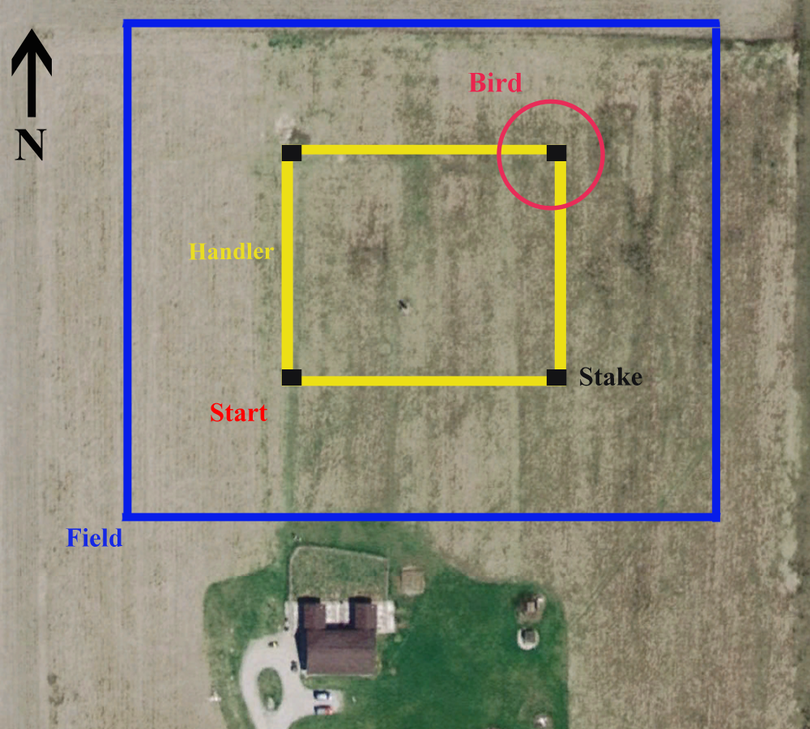

B
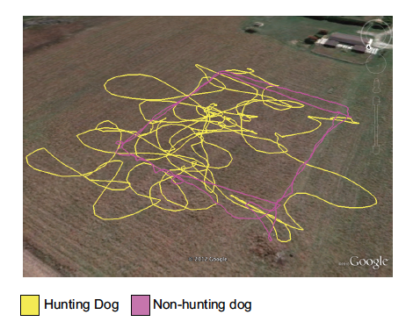
Figure 1A. Google Earth image showing the experimental field (blue), walking trail of the handler (yellow), stakes at four corners (black) and the position of target bird for the run, which commences at “Start”. B. Hunt trials (10min) of dogs illustrating markedly different spatial patterns.

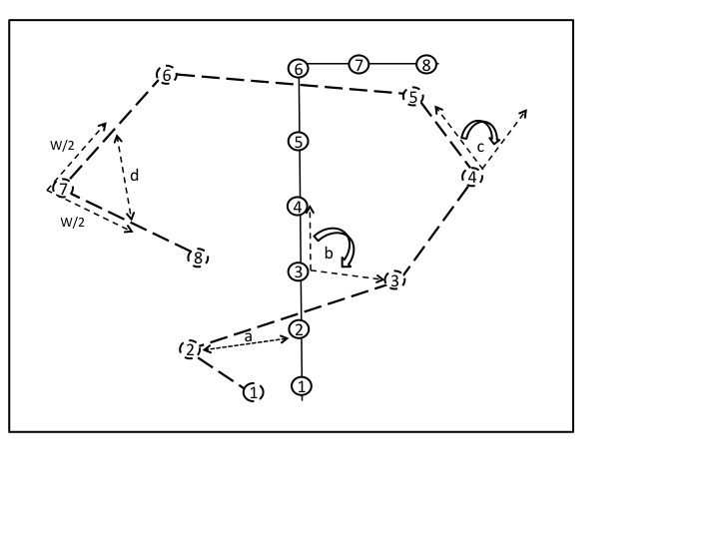
Figure 2. Mean speed, mean handler-dog distance (a), mean handler-dog angle (b), quartering ability, relative orientation of the dog (c), orientation consistency, fractal dimension, total area searched, and straightness of path at every move (D/W) was estimated from each trial.

Figure 3. Canonical centroid plot describing the separation of behavioral attributes between different types of dog breeds. Canonical axes 1 and 2 represent linear combinations of standardized behavioral measures plotted as vectors, extending outward in a direction that conveys correlation. The length and direction of vector lines signifies their ability to distinguish the body types. Positively correlated vectors face the same direction, negatively correlated in opposite directions, whereas uncorrelated vectors are orthogonal. The clustering of the data points for each dog type, represented as 95% confidence limit circles with a central multivariate mean, differ in size according to the sample size (small circle = large sample size), and are spatially separated by the most effective characters.

 | Training | Sex
 | Parameter estimate (p – value) | Parameter estimate (p – value)
Dependent measures
Mean speed | -0.015 (0.91) | -0.364 (0.56)
Variance in speed | -0.37 (0.43) | -2.71 (0.17)
Maximum speed | -0.32 (0.55) | -2.53 (0.26)
Index of straightness | 0.009 (0.16) | 0.021 (0.44)
Variance in Index of straightness | -0.003(0.3) | -0.009 (0.5)
Fractal dimension | -0.0002 (0.21) | 0.0005 (0.45)
Distance traveled | -6.63 (0.9) | -143.2 (0.51)
Mean distance to handler | 2.84 (0.33) | 3.57 (0.76)
Maximum Handler distance | 4.56 (0.49) | -3.13 (0.9)
Quartering ability | -0.66 (0.59) | -6.94 (0.18)
Total area searched | -0.0009 (0.9) | -0.029 (0.34)
Angular orientation | -0.145 (0.79) | -2.69 (0.25)
Relative orientation consistency | 0.006 (0.62) | 0.025 (0.63)
Mean dextral orientation to handler | -4.958 (0.34) | 4.88 (0.81)
Orientation consistency relative to handler | -0.002 (0.82) | 0.052 (0.34)

Table 1. Standardized partial regression coefficients from multivariate regression analyses conducted on two separate measures that could influence performance (training and sex) on behavioral characteristics.

Breed | N | MS | VS | MHD | VHD | MXHD | SI | VSI | FD | Q | MLO | OC | MDOH | OCRH
Brittany | 4 | 2.03 | 3.12 | 29.65 | 287 | 66.3 | 0.78 | 0.1 | 1.01 | 52.75 | 3.4 | 0.73 | 3.57 | 0.37
English pointer | 8 | 2.58 | 5.17 | 34.84 | 447 | 89.11 | 0.77 | 0.1 | 1.01 | 46.6 | 3.07 | 0.73 | 44.69 | 0.32
Control | 4 | 1.06 | 0.73 | 5.65 | 20.8 | 17.98 | 0.79 | 0.07 | 1.01 | 48.83 | 4.28 | 0.84 | 19.45 | 0.41

Table 2. Summary statistics for three types of dogs examined. The statistics for each type are Sample size (N), Mean Speed (MS), Variance in Speed (VS), Mean Distance to Handler (MHD), Variance in distance to Handler (VHD), Maximum Handler Distance (MXHD), Straightness Index (SI), Variance in Straightness index (VSI), Fractal Dimension (FD), Quartering Ability (Q), Mean Lateral Orientation (MLO), Orientation Consistency (OC), Mean Dextral Orientation to Handler (MDOH), and Orientation Consistency Relative to Handler (OCRH). Speed variables are in meters/sec, distance variables in meters, and angular measurements are in degrees. SI, VSI, FD, Q, OC, and OCRH are unit less (as these represent ratios).

Variables | F | p-value
MS | 8.71 | 0.01
VS | 7.77 | 0.005
MHD | 8.47 | 0.003
VHD | 7.11 | 0.007
MXHD | 10.81 | 0.005
SI | 0.37 | 0.55
VSI | 7.79 | 0.01
FD | 0.16 | 0.69
Q | 0.05 | 0.8
MLO | 0.94 | 0.33
OC | 8.44 | 0.01
MDOH | 0.39 | 0.54
OCRH | 1.81 | 0.19

Table 3. ANOVA table summarizing differences between different types of dogs based on the different objective metrics assessed from individual run of hunting and non hunting dogs.

Measurements | PC1 | PC2 | PC3 | PC4
Mean speed | 0.504 | -0.051 | 0.349 | -0.047
Area covered | 0.402 | 0.283 | -0.071 | 0.555
Straightness index | -0.134 | 0.478 | 0.385 | -0.109
Fractal dimension | -0.134 | -0.359 | 0.0578 | 0.622
Mean lateral orientation | 0.054 | -0.495 | 0.063 | -0.079
Orientation consistency | -0.419 | 0.444 | 0.035 | 0.179
Mean handler – dog distance | 0.479 | 0.192 | 0.327 | -0.125
Quartering ability | -0.057 | -0.183 | 0.55 | 0.307
Mean dextral orientation to handler | 0.229 | -0.085 | -0.281 | -0.246
Orientation consistency relative to handler | -0.289 | -0.199 | 0.477 | 0.285
Percent variance explained | 24.7 | 20.2 | 18.2 | 10.7
Cumulative variance explained | 24.7 | 44.9 | 63.1 | 74.8
Explanation of variables | Energetic searching | Linear running | Handler focus | Zigzagged exploring

Table 4. Factor loadings of a set of linear and circular dependent measures of dogs on the first four rotated principal components. Interpretation for each axis was made based on these factor loadings.

References
Batschelet, E. 1981. Circular Statistics in Biology. Academic Press Inc.
Bradshaw, J. W. & Goodwin, D. 1999. Determination of behavioural traits of pure-bred dogs using factor analysis and cluster analysis; a comparison of studies in the USA and UK. Research in veterinary science, 66, 73–76.
Cattell, R. B. & Korth, B. 1973. The isolation of temperament dimensions in dogs. Behavioral biology, 9, 15–30.
Club, A. K. 2006. The Complete Dog Book: 20th Edition. 20th edn. Ballantine Books.
Coppinger, R. & Coppinger, L. 2002. Dogs: A New Understanding of Canine Origin, Behavior and Evolution. University of Chicago Press.
Coren, S. 1994. The Intelligence of Dogs: Canine Consciousness and Capabilities. 1st edn. The Free Press/Macmillan.
Diederich, C. & Giffroy, J.-M. 2006. Behavioural testing in dogs: A review of methodology in search for standardisation. Applied Animal Behaviour Science, 97, 51–72.
Goodloe, L. P. & Borchelt, P. L. 1998. Companion dog temperament traits. Journal of applied animal welfare science: JAAWS, 1, 303–338.
Hare, B., Brown, M., Williamson, C. & Tomasello, M. 2002. The domestication of social cognition in dogs. Science (New York, N.Y.), 298, 1634–1636.
Hare, B., Plyusnina, I., Ignacio, N., Schepina, O., Stepika, A., Wrangham, R. & Trut, L. 2005. Social cognitive evolution in captive foxes is a correlated by-product of experimental domestication. Current biology: CB, 15, 226–230.
Hart, B. L. & Miller, M. F. 1985. Behavioral profiles of dog breeds. Journal of the American Veterinary Medical Association, 186, 1175–1180.
Jones, A. C. & Gosling, S. D. 2005. Temperament and personality in dogs (Canis familiaris): A review and evaluation of past research. Applied Animal Behaviour Science, 95, 1–53.
Lamb, V. 2006. The Ultimate Hunting Dog Reference Book: A Comprehensive Guide to More than 60 Sporting Breeds. Lyons Press.
MAHUT, H. 1958. Breed differences in the dog’s emotional behaviour. Canadian journal of psychology, 12, 35–44.
Mandelbrot, B. 1967. How long is the coast of britain? Statistical self-similarity and fractional dimension. Science (New York, N.Y.), 156, 636–638.
Martin, P. & Bateson, P. 2007. Measuring Behaviour: An Introductory Guide. 3rd edn. Cambridge University Press.
Miklosi, A. 2008. Dog Behaviour, Evolution, and Cognition. 1st edn. Oxford University Press, USA.
Miklósi, Á., Topál, J. & Csányi, V. 2004. Comparative social cognition: what can dogs teach us? Animal Behaviour, 67, 995–1004.
Netto, W. J. & Planta, D. J. U. 1997. Behavioural testing for aggression in the domestic dog. Applied Animal Behaviour Science, 52, 243–263.
Parker, H. G., Kim, L. V., Sutter, N. B., Carlson, S., Lorentzen, T. D., Malek, T. B., Johnson, G. S., DeFrance, H. B., Ostrander, E. A. & Kruglyak, L. 2004. Genetic Structure of the Purebred Domestic Dog. Science, 304, 1160–1164.
Plutchik, R. 1971. Individual and Breed Differences in Approach and Withdrawal in Dogs. Behaviour, 40, 302–311.
Podberscek, A. L. & Serpell, J. A. 1996. The English Cocker Spaniel: preliminary findings on aggressive behaviour. Applied Animal Behaviour Science, 47, 75–89.
Pongrácz, P., Miklósi, Á., Vida, V. & Csányi, V. 2005. The pet dogs ability for learning from a human demonstrator in a detour task is independent from the breed and age. Applied Animal Behaviour Science, 90, 309–323.
Ruefenacht, S., Gebhardt-Henrich, S., Miyake, T. & Gaillard, C. 2002. A behaviour test on German Shepherd dogs: heritability of seven different traits. Applied Animal Behaviour Science, 79, 113–132.
Savolainen, P., Zhang, Y., Luo, J., Lundeberg, J. & Leitner, T. 2002. Genetic evidence for an East Asian origin of domestic dogs. Science (New York, N.Y.), 298, 1610–1613.
Scott, J. P. & Fuller, J. L. 1998a. Genetics and the Social Behavior of the Dog. 1st edn. The University Of Chicago Press.
Scott, J. P. & Fuller, J. L. 1998b. Genetics and the Social Behavior of the Dog. 1st edn. The University Of Chicago Press.
Serpell, J. 1995. The Domestic Dog: Its Evolution, Behaviour, and Interactions With People. Cambridge University Press.
Slabbert, J. . & Odendaal, J. S. . 1999. Early prediction of adult police dog efficiency—a longitudinal study. Applied Animal Behaviour Science, 64, 269–288.
Svartberg, K. & Forkman, B. 2002. Personality traits in the domestic dog (Canis familiaris). Applied Animal Behaviour Science, 79, 133–155.
Van den Berg, L., Schilder, M. B. H. & Knol, B. W. 2003. Behavior genetics of canine aggression: behavioral phenotyping of golden retrievers by means of an aggression test. Behavior genetics, 33, 469–483.
Vilà, C., Savolainen, P., Maldonado, J. E., Amorim, I. R., Rice, J. E., Honeycutt, R. L., Crandall, K. A., Lundeberg, J. & Wayne, R. K. 1997. Multiple and ancient origins of the domestic dog. Science (New York, N.Y.), 276, 1687–1689.
Vonholdt, B. M., Pollinger, J. P., Lohmueller, K. E., Han, E., Parker, H. G., Quignon, P., Degenhardt, J. D., Boyko, A. R., Earl, D. A., Auton, A., Reynolds, A., Bryc, K., Brisbin, A., Knowles, J. C., Mosher, D. S., Spady, T. C., Elkahloun, A., Geffen, E., Pilot, M., Jedrzejewski, W., Greco, C., Randi, E., Bannasch, D., Wilton, A., Shearman, J., Musiani, M., Cargill, M., Jones, P. G., Qian, Z., Huang, W., Ding, Z.-L., Zhang, Y.-P., Bustamante, C. D., Ostrander, E. A., Novembre, J. & Wayne, R. K. 2010. Genome-wide SNP and haplotype analyses reveal a rich history underlying dog domestication. Nature, 464, 898–902.
William Arkwright. 1906. The Pointer and His Predecessors: An Illustrated History of the Pointing Dog ... A. L. Humphreys.
Wolters, R. A. 1961. Gun Dog: Revolutionary Rapid Training Method. Later Edition edn. Dutton Adult.

