MODELS OF SOCIAL RANK IN CRAYFISH

(Short title: SOCIAL RANK IN CRAYFISH)

Karlo Hock and Robert Huber

Department of Biological Sciences
J.P. Scott Center for Neuroscience, Mind & Behavior
Bowling Green State University, Bowling Green, OH 43403, USA

Correspondence to: Robert Huber, Department of Biological Sciences, Bowling Green State University, Life Sciences Building, Bowling Green, OH 43403, USA.
Tel: USA (419) 372-7492; Fax: USA (419) 372-2024; E-mail: lobsterman.bgsu@gmail.com

INTRODUCTION

Winner and loser effects, where individual’s past fighting experience affects its future success, are central to the development of dominance relationships among individuals. They do not alter the actual fighting ability of an individual, but rather affect its aggressive motivation, and these changes appear to be cumulative with each subsequent experience (Hsu & Wolf). These changes in aggressive motivation can then be manifested in two ways, either through perception by the receivers of the signals emitted by the winner/loser, or by altered perception of own fighting prowess through self-assessment (Rutte et al.). In either case, winner and loser effects are manifested in changes for future success; winner characteristics makes an individual more likely to win again, while the reverse is true for the losers. With such effects the need for iterated interactions is reduced between both familiar and unfamiliar individuals as an individuals own fighting behavior (e.g., approach and display in the early stages of an encounter) is changed depending the individual’s own past history (Hsu and Wolf).
Due to their importance for the establishment of dominance relationships, winner and loser effects have been documented empirically in a wide range of taxa (refs). Moreover, such effects have been the focus of theoretical models and simulations (refs, Hock & Huber 2006, 2007). While a significant portion of the published work has focused on dyadic interactions and dominance, an increasing body of work is emerging on the importance of winner and loser effects in larger groups, where they help form dominance hierarchies. In general, loser effects are often more pronounced and longer-lasting (refs) than winner effects and they alone appear sufficient to maintain hierarchical relationships and social structure (Hock & Huber 2006, 2007).
While the presence of winner and loser effects is widespread, the mechanisms that underlie them are not adequately understood. Current evidence suggests that proximate causes for winner and loser effects reside in neuroendocrine regulation of aggression (hormonal refs, Delago and Huber 1998; Huber 2005). Nevertheless, the adaptive side of winner and loser effects has received considerably less attention. The tradeoff between costs and benefits of fighting lies at the very heart of game theoretical analyses. It thus follows that if winner and loser effects are adaptive, they will contribute to maximizing this ratio. In social context, this means that this benefit/cost ratio will converge to optimality for both dominant and subordinate individuals in terms of differential access to resources. It is possible to partition the costs of fighting into several categories, namely costs associated with energy input into fighting, the risks of injury, and the increased exposure to predation. The benefits of fighting are generally associated with resource acquisition, but the fact that many animals fight their conspecifics even when the resources are not immediately present suggests that an increased winning probability is the resource in and of itself. Supported by numerous laboratory studies of animal aggression (refs) winning may serve to prime the animal towards acquisition of resources in the future.
Decapod crustaceans present the researchers with an model system in which animals fight for position even in the absence of resource both in the laboratory (Huberlab refs) or under field conditions (Davis and Huber 2007). In addition to frequent agonistic interactions, various aspects of winner and loser effects have been documented in Decapoda, from experimental manipulation of loser effects (Huber & Kravitz 1995) to their temporal dynamics (Bergman et al. 2003). Decapod crustaceans thus present an ideal system for developing theoretical models that explore such phenomena.
Our previous work on the relationships between the relative magnitude of winner-loser effects and the formation and maintenance of hierarchical structures (Hock & Huber 2006, 2007) has demonstrated that the relative magnitude of winner-loser effects was important for rapid divergence and structuring of a hierarchical structure, while a relatively high magnitude of loser effects was essential for its long-term stability. In the present study, through a series of spatially explicit agent-based models with strong links to the empirical studies, we aim to further explore the relationships between winner-loser effects and dominance hierarchies by placing the winner-loser effects in the context of the fighting costs in groups, as well as the benefits that they have for the individuals involved in formation of a hierarchy. By independently varying the winner and loser effects in the models, the results of this study will attempt to shed new light on the adaptiveness of winner and loser effects in animal conflicts.

METHODS
The models were developed using the Java programming language (Java 1.6.0 API). The parameters have been previously described in Hock & Huber (2006), and readers are advised to refer to that paper for further details on the modeling framework. {Karlo, add a short summary of the model here as well}

NON-BEHAVIORAL PARAMETERS
The general parameters were developed so as to resemble empirical experiments on decapod hierarchies (Goessmann et al. 2000). The arena, 270 by 180 pixels in size (an equivalent of 0.6x0.4m of actual space), was implemented as a ‘wrap-around’ world (where, animals exiting one side border would reenter the area from the opposite side) thus allowing for spatial movement patterns unaffected by obstacles. Four individuals per group were represented as single pixels, and were randomly placed in the arena at the start of each trial. Movements for each individual were randomly selected for every iteration from a distribution of 9765 empirically determined moves recorded on freely moving crayfish for 4s intervals (Panksepp & Huber 2004). Each iteration of the model thus represented a 4s timeframe. Each trial was run for 2700 iterations, or an equivalent of 3h.

INTERACTION RULES
The basic interaction rules were adapted from Hemelrijk (2000). In addition to spatial position, each individual was also characterized by a variable DOM representing its aggressive motivation and, as such, its relative probability of winning in an interaction. Each individual was given a DOM value of 0.5 at the start of each trial, thus leveling the chances to emerge as dominant within the group. Whenever two individuals came within a critical distance (DIST; equal to 27 pixels) of each other, their encounter developed into an interaction with associated consequences for their future success. Therefore, each individual was viewed as taking every opportunity towards increasing its own rank. The winner of an interaction is determined by comparing the DOM values of the two contestants, i and j, as per Equation 1.

(1) p_{W} = DOM_{i} / (DOM_{i} + DOM_{j})

An individual i will win over the individual j if its probability of winning p_{W} is greater than a randomly selected number from 0 to 1. Once the outcome of an interaction was determined, the aggressive motivation of each contestant was updated to reflect it as per Equations 2 and 3.

(2) DOM_{i(T+1)} = DOM_{i(T)} + (w_{i} – (DOM_{i(T)} / (DOM_{i(T)} + DOM_{j(T)}))) * STEPDOM
(3) DOM_{j(T+1)} = DOM_{j(T)} – (w_{i} – (DOM_{i(T)} / (DOM_{i(T)} + DOM_{j(T)}))) * STEPDOM

If contestant i was a winner, w_{i} was set to 1, else it was set to 0. The loser of an interaction would use an escape behavior instead of its next regular move by moving between one and three DIST values directly away from the winner.
From Equations 2 and 3 it follows that he subsequent changes in aggressive motivation were dependent not only on the outcome alone, but also on the relative difference in aggressive motivation between contestants and an additional scaling factor STEPDOM, which was used to represent interactions occurring at different maximum intensities. The likelihood of attaining any given intensity level is associated with the fight duration (Huber et al. 2004), and intensity levels have differential consequences on future fighting success (Beaugrand & Goulet 2000; Jennings et al. 2005). In accordance with the previously published characterization of decapod fights (Huber & Kravitz 1995; Huber et al. 2004), four discrete intensity levels have been implemented in the model, while the duration was not modeled directly but rather estimated as a level of aggressive motivation of an individual with a lower DOM value in a pair. Each intensity (ranging from 0 to 3) has been assigned a different STEPDOM factor, and STEPDOM was doubled for each increase in intensity level. The interdependence between a probability of attaining any given intensity level and fight duration (i.e. an escalation pattern) was implemented in the model as logistic regression curves obtained from pooled empirical data on dyadic, agonistic interactions (Huber & Delago 1998; Stocker & Huber 2001; Schroeder & Huber 2002).
The temporal dynamics of winner and loser effects suggest that changes in aggressive motivation gradually wear off with time. In Decapoda, winner effects decay to about 2/3 of the initial magnitude after a period of 40 minutes. Equation 4 indicates how this decay in DOM values that deviated from the resting state was implemented in the model.

(4) DOM_{decayed} = DOM_{(t)} – (DOM_{(t)} – 0.5)/(3N)

Any changes in DOM value as a result of interactions would eventually return to the resting value if no further interactions took place with such decay identical for both winner and loser effects.

WINNER/LOSER EFFECTS & COSTS/BENEFITS RATIO
Both winner and loser effects were modeled implicitly as context-dependent changes in aggressive motivation depending on past interaction outcome. Their manipulation was performed through the use of STEPDOM, thus making it possible to give different values not only to each intensity level, but also in order to independently combine different sets of STEPDOM values. It was thus possible to simulate, and therefore explore, how differential magnitudes of winner and loser effects and their relative differences influence the costs and benefits of fights and hierarchy formation within a group. Two different sets of STEPDOM values were used (High vs. Low) where High was set four times greater than Low. By independently combining these sets for winner and loser effects, four different scenarios, each with 50 replicates, were explored: High winner-Low loser effects (HL), Low winner-High loser effects (LH), High winner-High loser effects (HH), and Low winner-Low loser effects (LL).
Measurements of the social status of individuals was taken in regular intervals of 20 interactions within the group regardless of the identity of the involved individuals. Since each individual had an equal chance overall to meet any of the other three individuals as its next opponent, overall winning probability for each individual was calculated by pooling of the p_{W} values for that individual and dividing them by three. The cost of fighting was expressed in two ways: as an average duration of fights for an individual within the past 20 interaction interval, where duration was estimated as a DOM of the lower-DOM individual in the pair; and as a percentage of fights for an individual that reached intensity 3 within the past 20 interaction interval. These numbers were then classified per final ordinal rank of an individual in order to separately observe these parameters for each rank. {Karlo, complete this last paragraph ... The paper thus aimed to (1), (2), and (3)}

RESULTS
A total of 14,316 20-interaction intervals were recorded across the four model groups, with a range of 520-720 and a median value of 640 interactions per group. The number of interactions did not differ among scenarios. The final social status of an individual was determined by recording its cardinal rank using the Batchelder-Bershad-Simpson (BBS) method (Jameson et al. 1999) on its cumulative interaction history. In order to determine the hierarchical structure in a group, the degree of linearity of the hierarchy was calculated using Landau’s statistic h (Appleby 1983), which compares the number of transitive triads within a group to those maximally possible. The degree of linearity approached 1 (perfectly linear) in all models irrespective of the magnitude, or the relative magnitude, of winner and loser effects. However, linearity was achieved sooner in the models which had a higher magnitude of loser effects. The linearity results were consistent with those of Hock and Huber (2006).
The winning probability for an individual was primarily affected by the magnitude of loser effects, with low loser effects producing less of a difference in winning probability among dominants and subordinates (Figure 1). HL scenario resulted in constant winning probabilities for both dominants and subordinates, while LH scenario produced constant winning probability only for the subordinates. The difference in winning probability between dominants and subordinates thus progressively increased in all scenarios except HL scenario, while becoming more pronounced with the increase in relative importance of loser effects.
Average duration of fights decreased for both dominants and subordinates in all scenarios except HL scenario, where the fights rapidly reached maximum duration (Figure 2). Once at a maximum, fight duration then remained constant, indicating that the aggressive motivation of the subordinates remained at high levels with subsequent interactions. In cases where fight duration did decline, the speed of this decline was linked to the relative importance of loser effects (LL->HH->LH).
The high level of aggressive motivation across the group in HL scenario was evident in the degree of high intensity fights as well (Figure 3). When the percentage of fights that reached intensity 3 was concerned, an increasing number of intensity 3 interactions was observed for both dominants and subordinates in HL scenario. Other scenarios had similarly low percentage of interactions that escalated to the highest intensity.

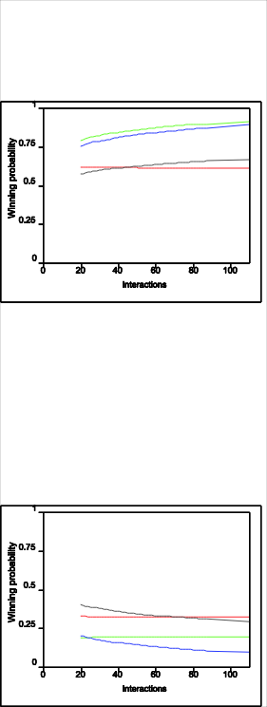
Figure 1. Winning probability for different models. Blue – High winner and high loser, gray – low winner and low loser, Red – high winner and low loser, Green – low winner and high loser effects

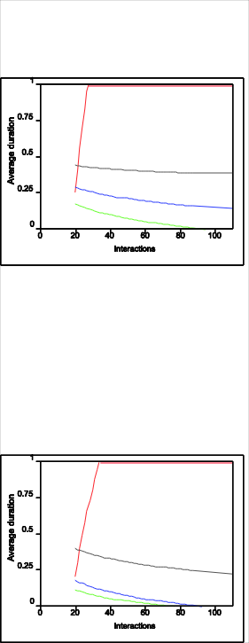

Figure 2. Average duration. Blue – High high, gray – low low Red – High winner-low loser effects, Green – low winner-high loser effects

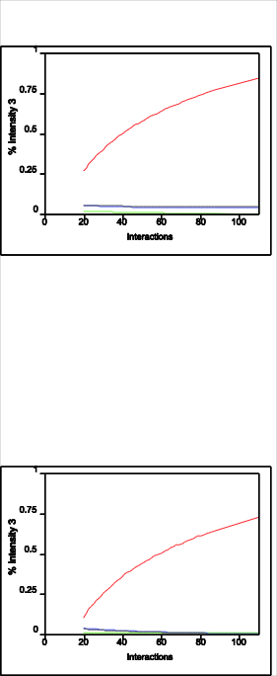

Figure 3. Percentage of fights ending at intensity 3. Blue – High high, gray – low low Red – High winner-low loser effects, Green – low winner-high loser effects

DISCUSSION

The importance of winner and loser effects for resolving animal conflicts has been the focus of many experimental studies and theoretical models (refs). These effects are the result of a series of decisions that an individual makes in agonistic interactions which ultimately affect its motivation and behavior. As behavioral conventions, they enable the individuals to maximize their access to resources while also retaining the ability to secure resources in future. This ability to secure future resources is immanently more important for the subordinates in a group who may lack them at present, which could explain why the abiding to conventions is generally more pronounced in subordinates, as evident by the number of studies in which the loser effects were stronger and longer lasting than winner effects (refs, Chase et al. 1994), to a point that sometimes winner effects were not detected at all (e.g. Schuett 1997).
Additional mechanisms, such as ritualized fighting featuring sequential assessment (Enquist & Leimar), further aid in minimizing the costs of fighting, particularly if fights could result in serious injuries for the combatants. On level of a group, winner and loser effects translate into a dominance hierarchy, and such social structuring reduces the need for future tests of resource acquisition ability. Thus, while the subordinates minimize their own fighting costs by exhibiting loser effects, the fighting costs of dominants is also indirectly reduced since they will have to expend less energy for fighting and enjoy lower risks while retaining their preferential access to current resources. The relative magnitude of winner and loser effects should thus have a profound effect on the costs and benefits of establishing and maintaining hierarchical relationships.
While the general reasoning behind the formation of a hierarchy is to reduce the risks of future conflicts, this was not the case for all examined scenarios. Specifically, when winner effects are higher than loser effects, the costs of fighting actually increased both in terms of longer fight durations, i.e. energy expenditure, and the intensity of fights, i.e. injury risks. Under such conditions, the aggressive motivation of the subordinates continued to increase despite the fact that they were losing many interactions. This was a result of the combination of two effects. Firstly, low loser effects translated into a relatively small overall decrease in aggressive motivation for the subordinates, even though those losses were frequent. The subordinates therefore remained poised to interact in longer fights and at higher intensities. Secondly, this tendency to interact at higher intensities subsequently meant that each win that they managed to achieve was likely to strongly propel their aggressive motivation into positive, thus overshadowing the effect of even a series of losses. Such wins were not only played out at a high intensity therefore having inherently larger returns and against opponents whose aggressive motivation was also relatively high, but also emphasized by the greater magnitude of winner effects. The winning probability of the subordinates was also comparatively high and constant, and therefore the subordinates under these conditions were more likely to achieve them than in other scenarios. But even without taking into consideration this effect, while the subordinates were poised to lose fights against the individuals of the highest rank, they were also interacting with those against whom their chances of winning were better. Thus, it was not necessary for them to win against the dominants to achieve these leaps in aggressive motivation, but rather any win was sufficient to attain such result.
The HL scenario therefore results in a group that is highly aggressive across the entire range of social ranks. There is very little difference between the fight dynamics typically experienced by the dominants and subordinates, with fights being markedly more aggressive than those in other scenarios. Furthermore, the winning probabilities of both dominants and subordinates are constant, meaning that hierarchical structure will not get reinforced with subsequent interactions. In effect, fighting history does little to influence the potential for future success beyond the initial divergence, and thus fights not only become more costly but also have less significance on the maintenance of social structure. The constant winning probability under the HL conditions could also explain the eventual convergence of ranks observed in the authors’ previous study on the relationships between hierarchical structure and relative magnitude of winner-loser effects (Hock & Huber 2006).
In contrast to the winner effect, the increase in the relative magnitude of loser effects is an effective mechanism to reduce the overall costs of fighting. Fight duration, and to some extent fight intensity, drop as loser effects become more important, and are the lowest in LH scenario. Under such conditions, the individuals that lose fights are rapidly profiled into subordinates, and lack the mechanism to regain their status with an occasional win against other low-ranking individuals due to the disproportional low winner effects. In effect, the mechanism that keeps the subordinates from changing their status is the inverse of the one under HL conditions, since the each odd win is more than offset by high-impact losses. Since the subordinates also experience a marked drop in their aggressive motivation, the fighting costs for the dominants are also indirectly reduced whenever they enter a fight against the subordinates. However, while the subordinates tend to participate in low-return fights, their winning probability nevertheless remains constant. In other words, while the subordinates reduce their costs of fighting by adjusting their fight dynamics, at the same time they retain the same probability to win for future interactions. While the immediate returns of this fact may be minimal, in a long-term maintaining the same winning probability could be potentially beneficial.
The results of the present study demonstrate that the low winner-high loser effect scenario resulted in a most favorable cost-benefit ratio of fights in a group irrespective of the final rank that an individual would achieve in the hierarchy. With disproportionally high winner effects the subordinates are not only unable to conserve the resources but also able to achieve little in terms of securing new resources in future. While proportional winner-loser effects also reduce the costs of fighting in groups, they do so more slowly and the costs are generally higher overall than under LH conditions. However, increasingly different winning probabilities among individuals of different rank in scenarios with proportional winner-loser effects could mean that such conditions could also be beneficial under certain conditions, such as cases when the costs of fighting, or acquisition of future resources, bears less weight than the present resource acquisition. It is thus not surprising that examples in nature almost exclusively feature either proportional winner-loser effects or cases where loser effects are more prominent.

Note: It would be great to see how all this pans out in the actual crayfish hierarchies… ☺
Also, I would really love to hear your thoughts on these additional things that could be integrated into this paper:
- Instead of a simple graph showing the percentage of intensity 3, I could put in a more complex graph detailing the pattern of probability for all intensities, such as the one we used in our second paper for figure 4
- Instead of using just the alpha and the delta of a group, I could produce the graphs for the other two ranks as well in all figures, and therefore have the inns and outs of how the things develop for intermediate ranks
- I could incorporate the initiation strategies into this and see how often individuals of a given rank turn encounters into interactions, basically seeing which initiation strategy gives the least amount of interactions necessary to achieve hierarchy; since costs are linked not only to the nature of the fights but also to how often they occur, this could be interwoven with the cost-benefit discussion, but it requires some adjustment to the entire text to accommodate the fact that I am not talking only about winner-loser effect any more
- I could do some additional analyses which would cover how stable the ranks are over time, i.e. how often they change and what is the ability, or the probability, of an individual to retain its rank, again partitioned for each final rank; this could be interesting to see in which scenario the subordinates have the greatest ability/potential to change their fate later on, thus feeding into the discussion about retaining the potential to win in future fights by abiding to the behavioral conventions at present

